Menu
16 februari 2026
Regatta Hiskaatje

Squeezy Tortellini
Italian Stallion balls
Fricandeau tonnato – Salad in a bowl
Cheese platter
Sergio’s Salami

Do not be shy to order your extra
Olives – Artichoques – Bread - Courgette
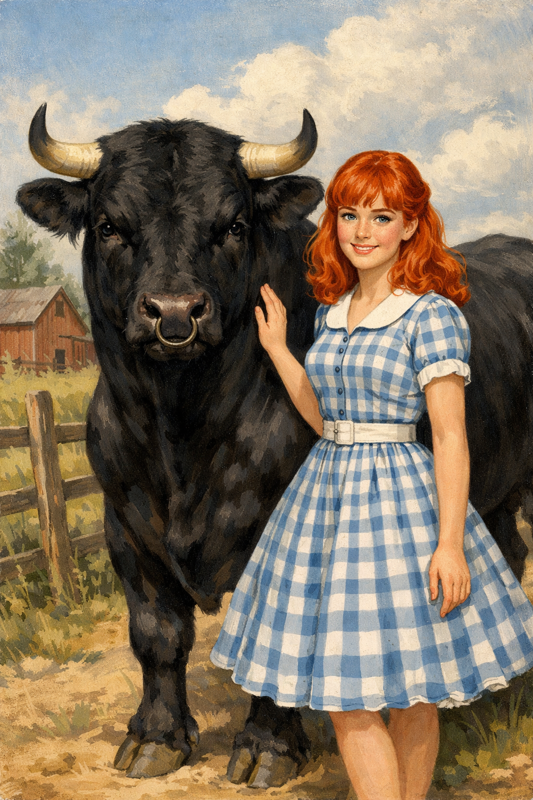
Drinks
Organic red wine
Primitivo (It)
Carmenere (Fr)
Bobal (Sp)

Sparkling water
Aqua Panna
Pellegrino

Sour Beer

-

Host and table guest: Mattia, expert in listening and holding hand
Cook: Valentino, specialized in giving compliments and winking
Special treats: Sergio, master in external and internal massage
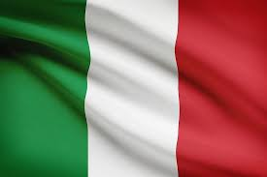
Il toro e la ragaza is powered by Perruche a Collier

